AI4I 2020 Predictive Maintenance
Full Project Report

Date: April 23, 2026 | Author: lightgo | lightgo1230@gmail.com

1. Project Overview
This project applies a PyTorch-based Multi-Layer Perceptron (MLP) to the AI4I 2020 Predictive Maintenance Dataset for binary classification of machine failures. The trained model is packaged into a fully standalone Windows desktop application built with Rust and the egui GUI framework, requiring no Python or external dependencies.

1.1 Objectives
- Predict machine failure (binary: Normal / Failure) from industrial sensor data
- Handle severe class imbalance (28.5:1) via BCEWithLogitsLoss pos_weight
- Deploy as a self-contained Windows executable with real-time inference UI

2. Dataset
2.1 Overview
Item | Detail
Source | AI4I 2020 Predictive Maintenance Dataset
Total Samples | 10,000
Normal | 9,661 (96.6 %)
Failure | 339 (3.4 %)
Class Imbalance | ~28.5 : 1
Missing Values | None

2.2 Features
Feature | Type | Preprocessing
Machine Type (L/M/H) | Categorical | One-Hot Encoding → 3 columns
Air Temperature [K] | Numerical | StandardScaler
Process Temperature [K] | Numerical | StandardScaler
Rotational Speed [rpm] | Numerical | StandardScaler
Torque [Nm] | Numerical | StandardScaler
Tool Wear [min] | Numerical | StandardScaler
TWF/HDF/PWF/OSF/RNF | Excluded | Data leakage prevention

2.3 Exploratory Data Analysis
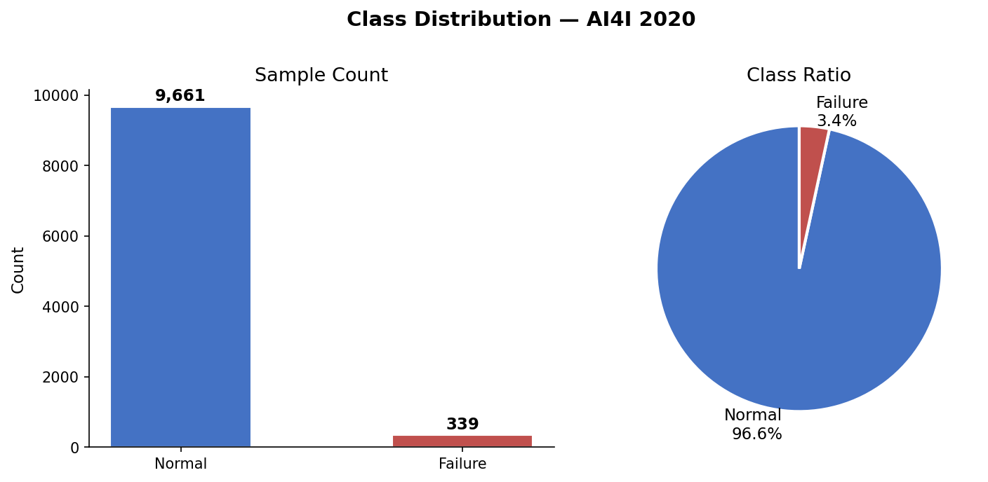
Fig 1. Class Distribution
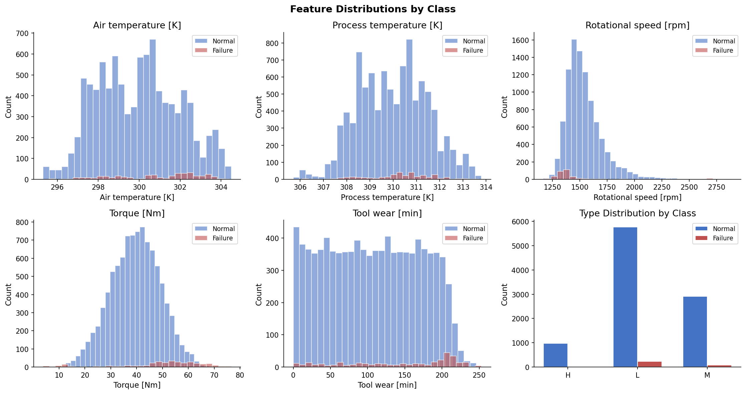
Fig 2. Feature Distributions by Class
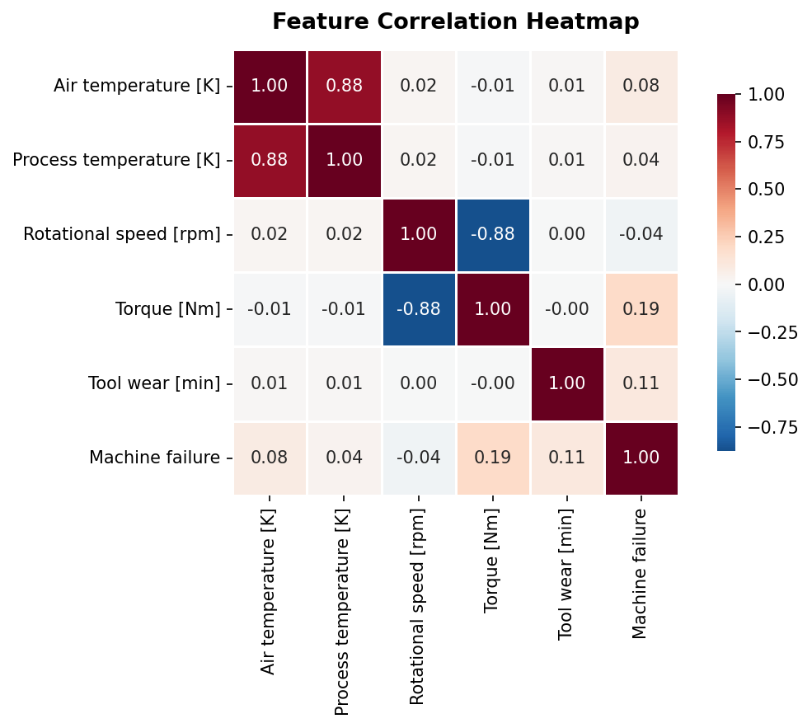
Fig 3. Feature Correlation Heatmap

3. Model Architecture
3.1 Network Structure
A Multi-Layer Perceptron (MLP) was designed for tabular binary classification. Input dimension is 8 (5 scaled numerical + 3 one-hot encoded). BatchNormalization and Dropout regularize each hidden layer.

Layer | Output | Activation | Regularization
Input | 8 | — | —
Linear + BatchNorm | 128 | ReLU | Dropout 0.3
Linear + BatchNorm | 64 | ReLU | Dropout 0.3
Linear + BatchNorm | 32 | ReLU | —
Linear (Output) | 1 | Sigmoid (in loss) | —

3.2 Training Configuration
Item | Setting | Rationale
Loss | BCEWithLogitsLoss | Numerically stable; supports pos_weight
pos_weight | 28.50 | = 9,661 / 339 — corrects class imbalance
Optimizer | Adam lr=1e-3, wd=1e-4 | Fast convergence + L2 regularization
LR Scheduler | ReduceLROnPlateau ×0.5 / patience=7 | Halve LR on F1 plateau
Batch Size | 256 | —
Early Stopping | patience=20, metric=Val F1 | Prevent overfitting; restore best weights

3.3 Training Curves
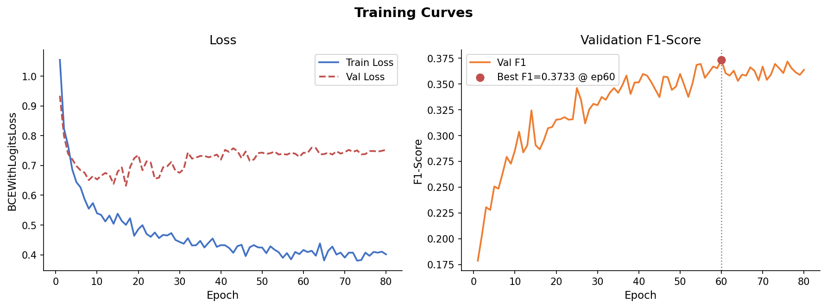
Fig 4. Training Loss & Validation F1

4. Experimental Results
4.1 Hold-Out Test Results (Train 70% / Val 15% / Test 15%)
Metric | Value | Note
AUC-ROC | 0.9727 | Excellent discrimination
Recall | 0.9216 | 47 / 51 failures detected
F1-Score | 0.3837 | Limited by low Precision
Precision | 0.2423 | 47 TP out of 191 predicted failures
Accuracy | 0.8967 | Misleading metric under imbalance

Note: In predictive maintenance, missing a real failure (FN) is far more costly than a false alarm (FP). Recall and AUC-ROC are therefore prioritised.

4.2 Confusion Matrix
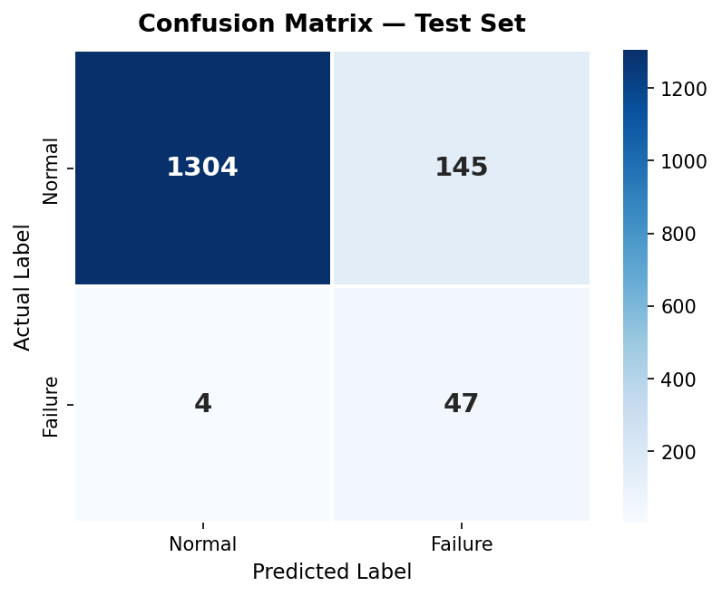
Fig 5. Confusion Matrix (Test Set)
4.3 ROC & Precision-Recall Curves
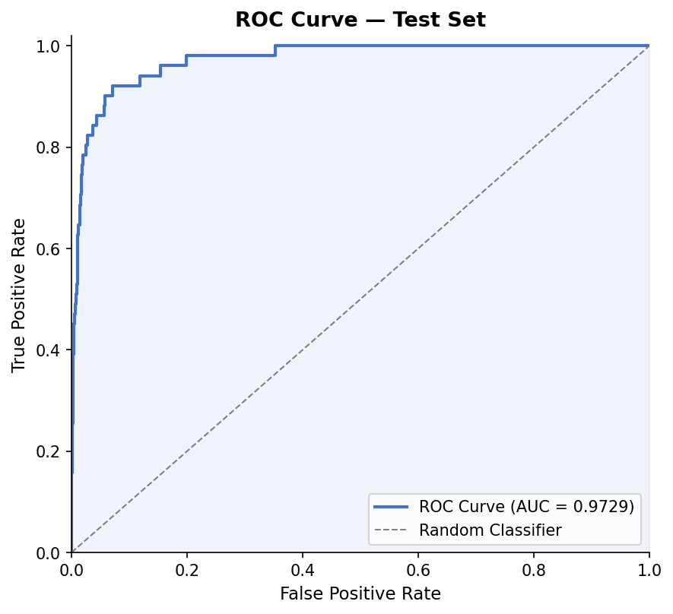
Fig 6. ROC Curve (AUC = 0.9727)
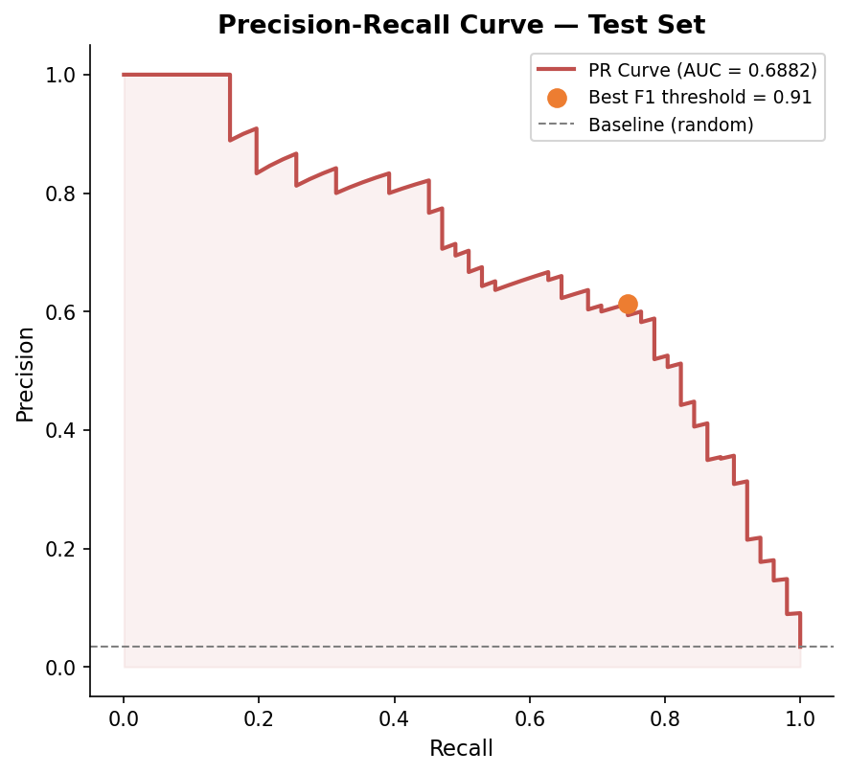
Fig 7. Precision-Recall Curve
4.4 Threshold Analysis
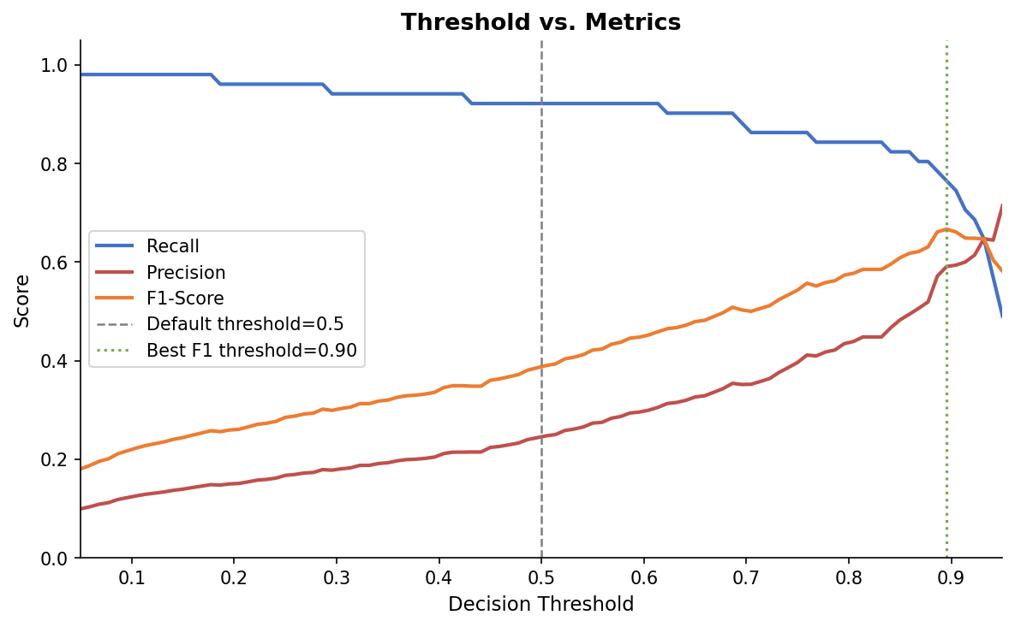
Fig 8. Threshold vs. Metrics

4.5 5-Fold Stratified Cross-Validation
Fold | F1-Score | Recall | AUC-ROC
Fold 1 | 0.3974 | 0.8955 | 0.9620
Fold 2 | 0.3509 | 0.8824 | 0.9672
Fold 3 | 0.4296 | 0.8971 | 0.9703
Fold 4 | 0.3922 | 0.8824 | 0.9599
Fold 5 | 0.4545 | 0.8824 | 0.9658
Mean ± Std | 0.4049 ± 0.0352 | 0.8879 ± 0.0068 | 0.9650 ± 0.0037

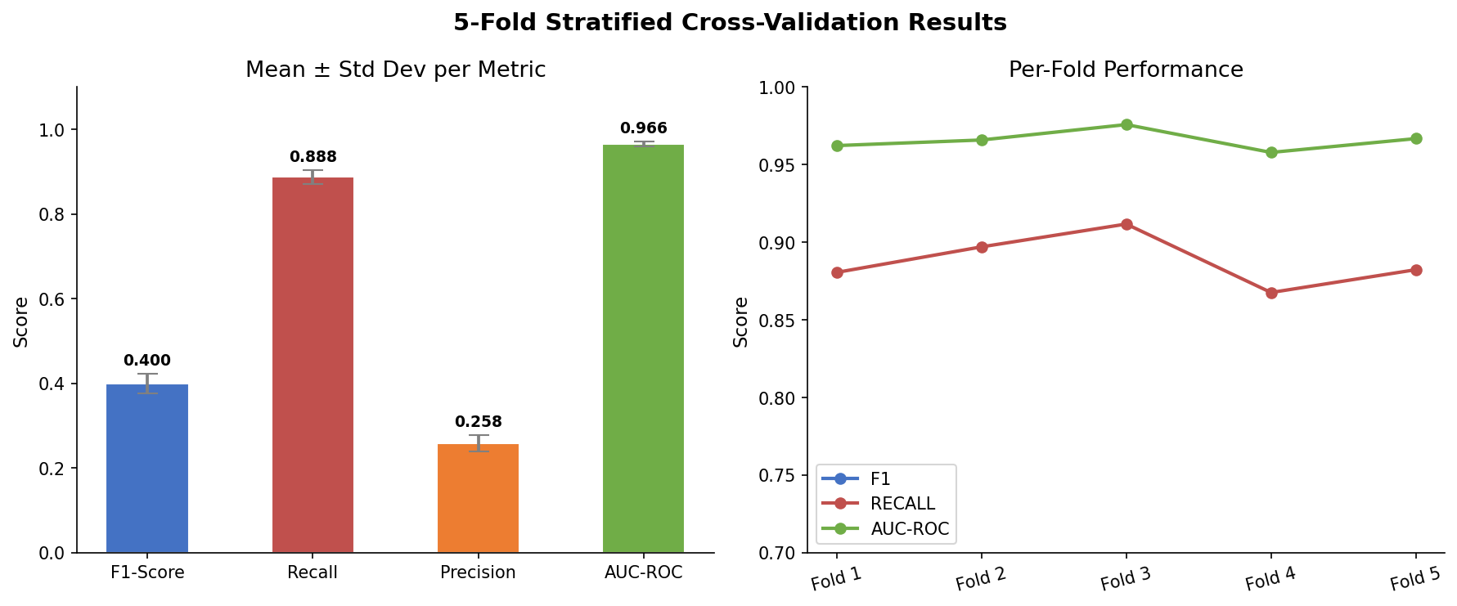
Fig 9. 5-Fold Cross-Validation
4.6 Predicted Probability Distribution
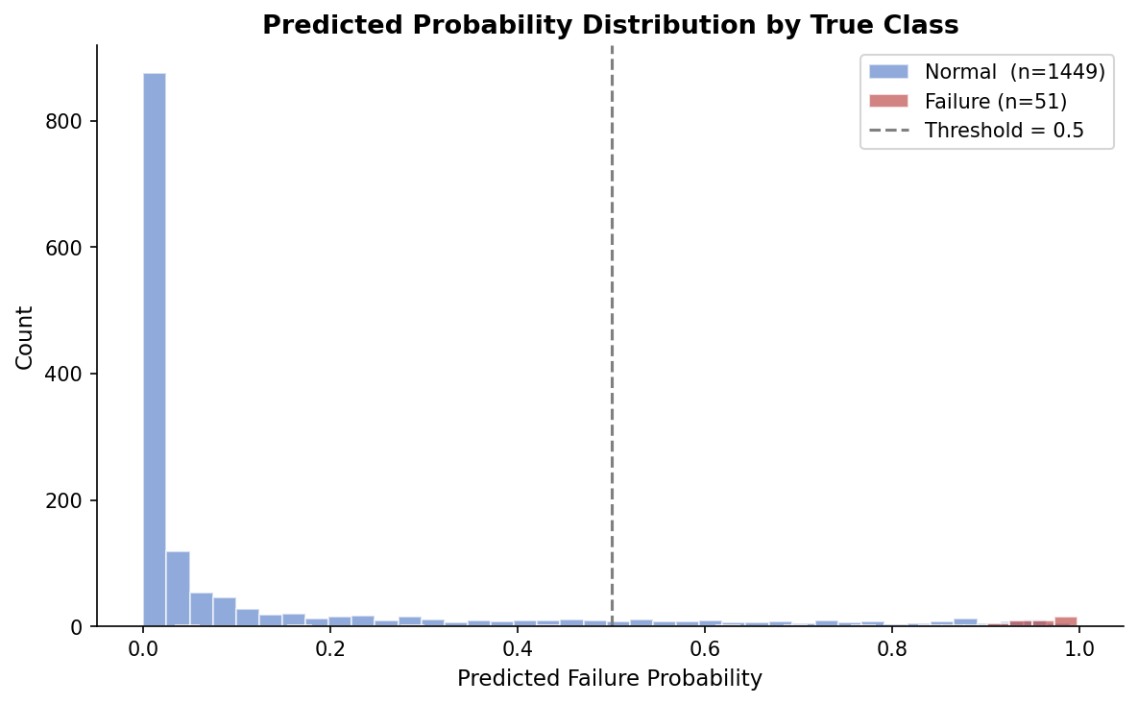
Fig 10. Predicted Probability Distribution

5. Desktop Application
The trained model is embedded into a standalone Windows executable (8 MB) developed with Rust and the egui 0.29 GUI framework. All assets — model weights, fonts, and icon — are compiled into the binary.

5.1 Technology Stack
Layer | Technology
Model Training | Python · PyTorch · scikit-learn
Desktop UI | Rust · eframe · egui 0.29
Font Rendering | Segoe UI + Segoe UI Symbol (embedded)
Executable Icon | winresource (.ico embedded)
Model Weights | include_str! — 252 KB JSON baked in
C Runtime | Statically linked (crt-static) — no DLL dependency

5.2 Key UI Features
- Real-time prediction gauge updating on every slider change
- Semicircular probability gauge with color-coded risk levels
- Adjustable decision threshold (0.10 – 0.90)
- Prediction history table (up to 50 entries per session)
- Fully portable — runs on any Windows 10/11 machine without installation

5.3 Risk Level Reference
Color | Probability | Risk | Recommended Action
Green | 0 – 30 % | LOW | Normal operation
Yellow | 30 – 55 % | MEDIUM | Increase monitoring frequency
Orange | 55 – 75 % | HIGH | Schedule maintenance soon
Red | 75 – 100 % | CRITICAL | Immediate inspection required

6. Conclusion & Future Work
6.1 Summary
The MLP model achieves AUC-ROC 0.9727 and Recall 0.9216 on the hold-out test set, demonstrating strong ability to detect machine failures in a severely imbalanced dataset. The 5-Fold CV confirms stable generalisation (AUC 0.9650 ± 0.0037). The accompanying desktop application makes the model immediately usable by operators without any technical setup.

6.2 Future Improvements
- Threshold optimisation via Precision-Recall curve analysis
- SMOTE / oversampling to improve Precision
- ResNet-style skip connections for deeper tabular models
- Ensemble with XGBoost / LightGBM for further accuracy gains
- Multi-label output for individual failure mode (TWF/HDF/PWF/OSF/RNF) prediction
- CSV export of prediction history from the desktop application

© 2026 lightgo · lightgo1230@gmail.com · All rights reserved.

